***Developmental changes in the ability to draw distinctive features of object categories***

Bria Long, Judith E. Fan, Zixian Chai, Michael C. Frank

Department of Psychology, Stanford University

Children draw prolifically from an early age, providing a rich source of insight into their emerging understanding of the world. Here, we investigate developmental changes in children’s ability to emphasize the relevant visual distinctions between object categories in their drawings.

To do so, we developed a tablet-based platform to collect a large number of children’s drawings (5368 drawings, 1259 participants aged 2-10 years) via a free-standing drawing station in a science museum. In each session, children could produce drawings of up to 16 different object categories. On each trial, a video verbally cued a particular object category (“Can you draw a dog?”); children then had up to 30 seconds to complete their drawing.

We hypothesized that drawings produced by older children would be more recognizable. To evaluate this prediction, we first applied a pretrained deep convolutional neural network model (VGG-19) to extract a high-level feature representation of all drawings. We then trained a 16-way logistic regression model under leave-one-out cross-validation to estimate the recognizability of drawings produced by children in each age group. The model’s classification accuracy increased with age, even when controlling for low-level covariates (time spent drawing, ink used, or number of strokes). This pattern replicates results from a smaller, human-rated sample of recognition judgments (*N*=14 raters, 256 drawings).

To investigate the underlying source of these changes in recognizability, we computed the mean feature vector (*center*) and the mean squared distance of drawings from the category center (*dispersion),* for each age and category. We found both that the overall distance between category centers increased and that within-category dispersions decreased with age, suggesting that older children may have an increasing ability to include category-diagnostic information in their drawings. Future work will relate these changes in visual production ability to changes in fine motor control and object categorization.

*Word count: 297/300*

*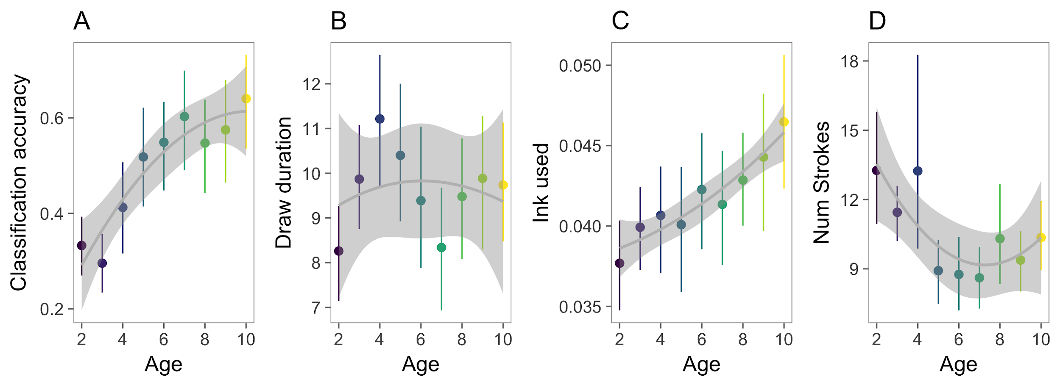****Figure 1.***Leave-one-out classification accuracy (A), the amount of time spent drawing in seconds (B), the amount of ink used (i.e., mean intensity of the drawings) (C), and the number of strokes used (D) are plotted as a function of children’s age.

.***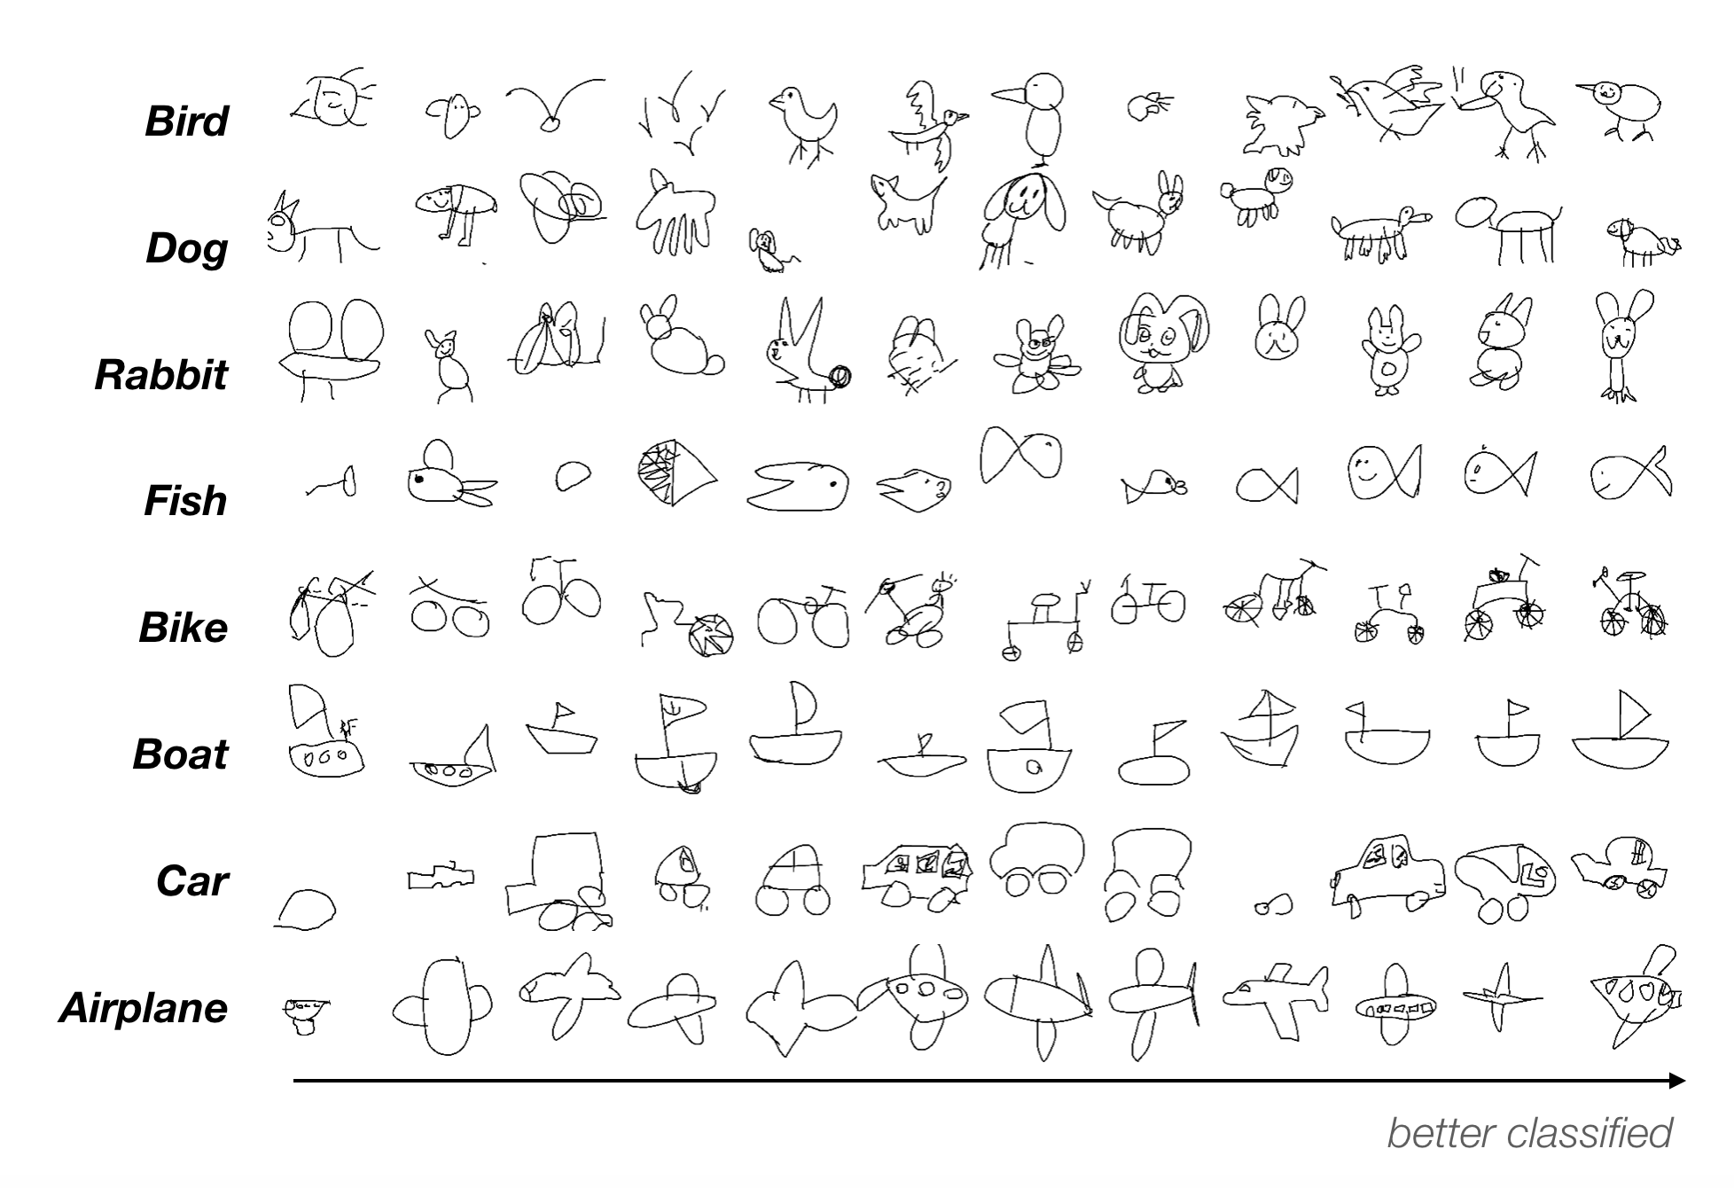Figure 2.***Randomly sampled drawings from eight categories ordered by the probability that the sketch was assigned to the correct target category; all sketches depicted here were correctly classified.